
Annual

Procurement
Report
2025
/
2026

Contents
Introduction Page 3

Summary of regulated procurement completed Page 4

Review of regulated procurement compliance Page 4

Social (community) benefits summary Page 4

Supported businesses and social enterprises Page 10

Sustainability Page 12

Future regulated procurements Page 13

Annual Procurement Report owner Page 13

Appendix 1: Outcomes achieved Page 14

Annex A: Summary of regulated procurements Page 18

Annex B: Regulated procurements Page 22

Annex C: Non-compliant regulated spend Page 28

Annex D: Future regulated procurement Page 31

Introduction
1.1 In accordance with Section 15 of the Procurement Reform (Scotland) Act 2014, the Council published its Sustainable Procurement & Commercial Strategy (Strategy) for the period 2021 to 2026. An update has also been published to cover the period 2026 to 2027 Section 18(2) (a) of the Procurement Reform (Scotland) Act 2014 requires the Council to detail “...a summary of the regulated procurements that have been completed during the year covered by the report".

1.2 This Annual Procurement Report (APR) outlines the key elements of regulated procurements for the period 1 April 2025 – 31 March 2026. Regulated procurement refers to any procurement from £50k for Supplies and Services contracts and from £2m for Works contracts. A regulated procurement is completed when the award notice is published or where the procurement process otherwise comes to an end. Regulated procurements can refer to procurements delivered through new contracts or from utilising framework agreements (FA) or dynamic purchasing systems (DPS).

1.3 The Strategy is closely aligned to the Council’s vision, values and ethos and describes the role procurement has in supporting the delivery of the Council’s Strategic Plan. It sets out the key procurement objectives of the Council for 2021 to 2027. The delivery of these objectives will support the Council as it continues to face significant challenges, including:
- Resilience planning;
- Cost of living crises;
- Inflation in cost of supplies and global supply chain shortages;
- Building a stronger community through commissioning services which aim to give more power to the community and promote community action;
- Supporting services to meet financial requirements;
- Continuing to proactively engage with all sectors across the local economy;
- Sustainability and Climate Change duties

  - Appendix 1 and Annex A to D sets out the regulated procurement achievements, actions and future plans for the Council, which includes West Dunbartonshire Health and Social Care Partnership (WD HSCP). The Scottish Government’s Annex A: Summary of Regulated Procurements, is detailed in this report.

  - The Council also maintains a public (Contract Register) Contract Register which provides information on current contracts.

Summary of regulated procurement completed
2.1 Details of regulated procurements awarded by the Council between 1 April 2025 and 31 March 2026 can be found at Annex B: Regulated Procurements and Annex A.

2.2 Collaborations with other public bodies to maximise mutual benefits, where appropriate, are included in the regulated procurements. This includes Scottish Government, CoSLA, Government Commercial Agency (previously Crown Commercial Services), Scotland Excel and the Council all acting as the contracting authority when procuring Supplies, Services and Works.

2.3 Number of regulated contracts awarded without a competitive procurement process was zero.

Review of regulated procurement compliance
3.1 Based on an analysis of spend data, of the £207,108,570 total regulated procurement spend, 91.8% / £190,103,818 (Council and West Dunbartonshire Health and Social Care Partnership) was compliant with regulated procurements. As a subset of this spend, the Council only expenditure (i.e. total spend excluding Health and Social Care Partnership) totalling £141,964,977 regulated procurement spend, 97.4% / £138,229,709 was compliant with procurement regulations.

3.2 The summary detail is shown in Annex C: Non-Compliant Regulated Spend and also highlights where further work is required to achieve increased rates of compliance. Where there has been non-compliance with procedures, this is partly due to separate spend from different Council departments which when combined, is higher than Financial Regulation limits.

3.3 All compliant over £50k spend is advertised publicly either via Public Contracts Scotland as part of tender exercises conducted by the Council or by framework bodies such as Scottish Government, Scotland Excel, Scape or Scottish Procurement Alliance. We also utilise Government Commercial Agency frameworks which are advertised openly on the UK Find a Tender Service, in line with legislation. Evaluation must always make sure equal treatment is undertaken in a proportionate, objective, transparent and non-discriminatory manner. The Councils evaluation panel should be able to withstand any scrutiny. A conflict-of-interest form will be completed prior to evaluation of each tender and to ensure that this includes any potential conflict of interest which would prevent them from making a fair and objective tender assessment.

3.4 For spend between £10k and £50k, where no existing contract is available, opportunities will be advertised via Public Contract Scotland – Quick Quotes.

Social (community) benefits summary
4.1 The Council is committed to working with our local community and businesses to maximise local social value.

4.2 The Council has implemented specific clauses within procurement contracts of more than £50k, known as social benefit clauses. Social benefit clauses are requirements which deliver wider benefits to our local community in addition to the core purpose of a contract. These clauses can be used to build a range of economic, social or environmental benefits into Council contracts through a range of options which may include, but are not limited to:
- Employment, work experience, training or modern apprenticeship opportunities;
- Education engagement and curriculum support activities;
- Support for community and environment projects through donation of money, labour, equipment or materials; and
- Other initiatives to support and develop local businesses, community groups and the local third sector

4.3 The social benefits questionnaire is part of the procurement documentation issued to all bidders of Council tenders and includes target social benefits points based on the annual value of the contract. This is a transparent, fair and accountable approach for assessing the impact of Social Benefits. In FY25/26 social benefits totalled:

Total Donations Working4U Received 25/26
Cash Donations | £26,681
Value of Materials | £4,920
Labour / courses, inputs, etc. | 201 hours
Cost in Kind | £2,703.45
Work experience weeks | 34
Employment opportunities | 7

4.4 Examples of a social benefit good news stories in 2025/26 include:
Exxon Infrastructure Development Project
As part of Balfour Beatty’s commitment to delivering meaningful social value, the Project Team were proud to support Improving Lives, a Clydebank based charity providing vital support for people with disabilities, their families and carers across West Dunbartonshire
Across two days, a total of 20 volunteers from the Exxon redevelopment site in Dumbarton and Balfour Beatty’s Head Office at Maxim Park joined forces with charity volunteers to deliver a full internal refresh of the organisation’s community hub.
Working collaboratively, volunteers repainted the entire premises, creating brighter, calmer and more welcoming spaces for those who rely on the charity’s services.
This activity was made possible through the dedication and enthusiasm of the Balfour Beatty team, alongside materials provided by the Exxon redevelopment site.
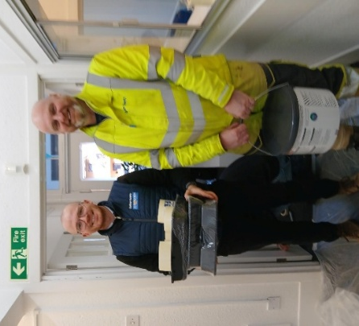
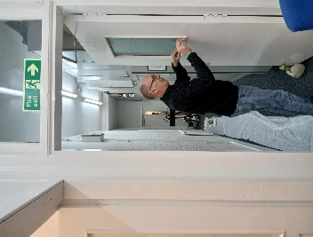
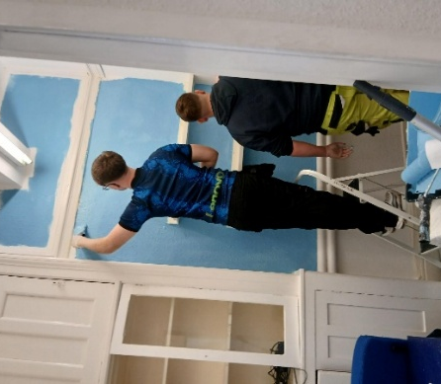
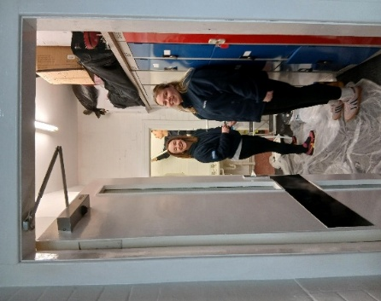
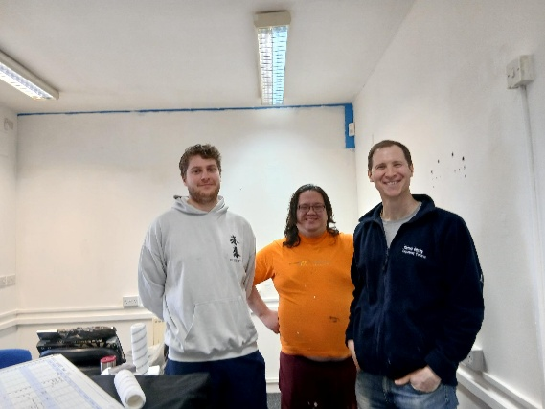

This work reflects the positive impact that social benefits can deliver in West Dunbartonshire and demonstrates social impact at its best, improving spaces, strengthening community partnerships and supporting those who need it most.

Arnold Clark
“Arnold Clark has recently generously donated £2,000 to support two fantastic local charities in Clydebank – The Clydebank Men’s Shed and Golden Friendships. This contribution will help both organisations continue their invaluable work in the community, providing social opportunities, support, and a welcoming space for people to connect and thrive. A huge thank you to Arnold Clark for making a real difference locally!”
Clair McCarron, Arnold Clark: At Arnold Clark we believe that by giving back to our communities today, we can help build a better future for generations to come. We try to support as many charities and community groups like Men’s Shed and the Golden Friendship Group as we can in order to care for and strengthen the local areas where we live and work.”
Jim McLaren, Golden Friendships: “Thank you so much for your donation. We are now able to buy an industrial fridge to store our food as we were using a commercial one. We have served 750 free Christmas dinners in our efforts to tackle loneliness in the community, and we are currently serving up to 100 free dinners every Tuesday night from the start of October until the end of March through our project called Heating and Eating, to help anyone struggling with the current cost-of-living crisis.”
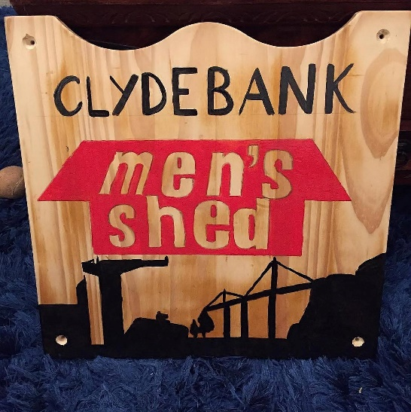
Chris Laws, Clydebank Men’s Shed: “The very generous donation of £1000 from Arnold Clack, has enabled us to replace two old and decrepit machine tools that are vital to us here at Clydebank Men’s Shed. We use these machines on a daily basis on projects for our local community. This is a vital source of revenue, which helps to keep us afloat financially”

BT Volunteer days with Bonhill Community Garden
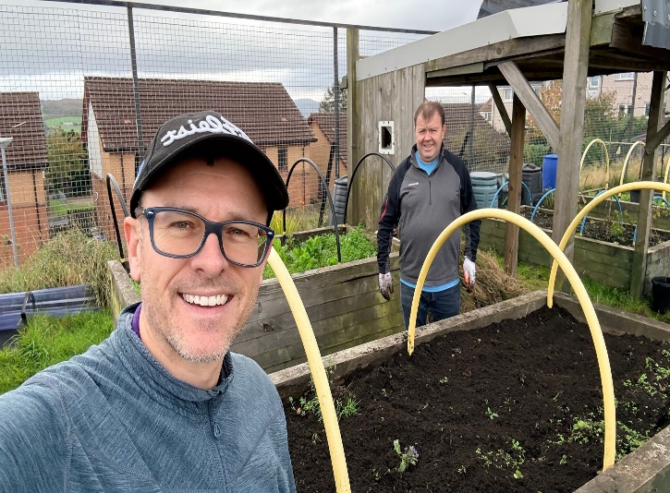
Two senior BT staff members volunteered for two days with Bonhill Community Garden on the 8th and 9th of October 2025. They spent the time clearing areas of the garden, cutting grass, pruning, and weeding.
John Goy - Private Networks & IoT Solutions Consultant said “BT thoroughly enjoyed a recent volunteer working party experience with Bonhill Community Garden, a brilliant project where the local community has taken over an uncared-for part of their estate and turned it into an oasis of nature and community”
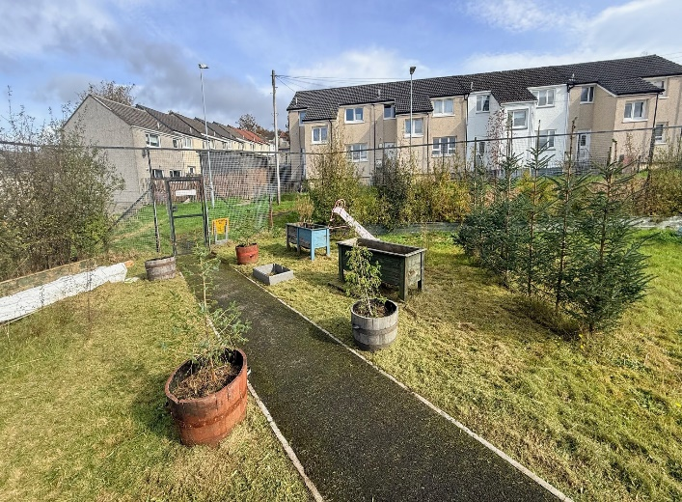
Brian Jackson – Director of BT Surveillance & Smart Solution said “Although the gardening, grass cutting and tree pruning was hard work, the effort was certainly worth it and to stand back at the end of 2 days and see the positive visual impact was very satisfying. I can say that the two of us that worked with the team certainly got a positive boost to our mental health. This was a brilliant experience”
Catherine Howard Secretary Bonhill Community Garden
“We have constant weeding, grass cutting, and shelter belt hedging to tend to, and both John and Brian jumped straight in. The difference they made is fantastic. Many of our volunteers feel comfortable taking on tasks they’re able to manage, which often leaves the more strenuous and tiresome jobs to those more able, like John and Brian. The work they carried out made a real difference to the morale of the group. Volunteers can now freely manage these areas, and we aim to repurpose the raised beds to form a new strawberry patch. Their input was incredibly valuable and beneficial to both us volunteers and our growing space.”

The Willox Park Development
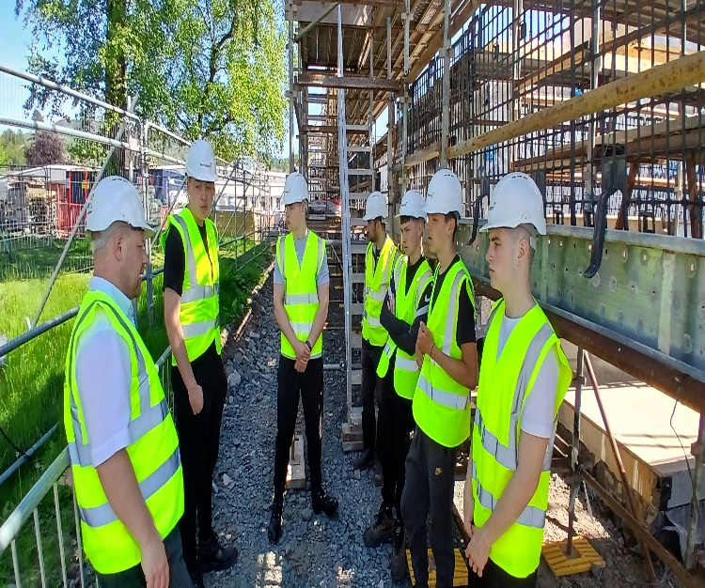
Pupils in their Senior Phase years at school, from S4 to S6, can choose a Foundation Apprenticeship as one of their school subjects. During the apprenticeship, learners work on employability skills, gain an understanding of the industry and the job roles within the sector, and collaborate on a project to meet a brief from a real client. They also develop practical skills in painting and decorating, bricklaying, and joinery. McTaggart Construction was very keen to support the Foundation Apprenticeships and provided six pupils with a five-week programme consisting of a series of planned interventions.

Ross Hammel, McTaggart Construction: McTaggart is committed to supporting the next generation of the construction workforce. The Willox Park development has been used to enhance industry learning and support the WDC Foundation Apprenticeship programme.
These site-based learning opportunities not only promote the construction industry but also provide a unique and valuable environment for young people interested in the built environment.

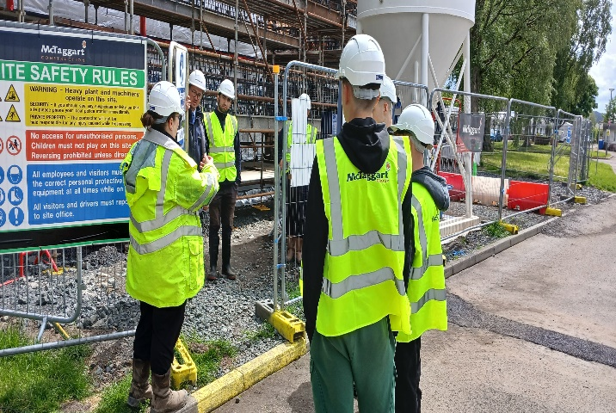
Stephen Knox, Working4U: Ross and the team at McTaggart's provided work placements for our Civil Engineering Foundation Apprentices. The experience included a combination of professional talks, hands-on activities, and site observations. Topics covered various aspects of the construction industry, such as health and safety, engineering, quantity surveying, and sustainability, among others. The placement not only supported the young people in completing their qualifications but also gave them valuable insight into the industry as a whole. Participants found it both interesting and informative to learn about the different career opportunities within the construction sector, and they enjoyed observing the work being carried out on-site. This experience was essential for the apprentices to complete their course and helped them become more knowledgeable about the construction industry overall.

4.5 As reported in last years annual procurement report, a first ever joint West Dunbartonshire Meet the Real Buyer event took place on 27 March 2025, at Golden Jubilee Conference Hotel. During this financial year the procurement team worked closely with the Supplier Development Programme to deliver supplier engagement events for the multi-lot backup contractor framework. This support encourages additional competition as well as providing support for new bids, particularly from small to medium sized enterprises.

Supported businesses and social enterprises
5.1 Unfortunately, as there is not a central directory which supported businesses and social enterprises must register, it can be difficult to clearly identify spend in this area.

5.2 A supported business’ primary aim is the social and professional integration of disabled or disadvantaged persons. At least 30% of the employees of those businesses must be disabled or disadvantaged. This is delivered, not only through the supplies, services and works they deliver, but also by providing meaningful employment, training and social support for those who may otherwise be excluded from the workplace.

5.3 There was no regulated contracts awarded to supported businesses during 2025/26 (noting the point in 5.1 that this can be difficult to identify). However, in 2025/26, the Council had spent with supported businesses including regulated contracts awarded before 2025/26 and non-regulated spend:

Supported Business Supplier | West  Dunbartonshire  Based | 2025/26 Spend
City Building (CONTRACTS) LLP (subcontracted to Royal Strathclyde Blindcraft Industries) | No | £205,896
Hey Girls CIC | No | £16,034
Royal British Veterans | No | £6,930
Royal British Legion Industries Ltd | No | £3,856

5.4 Social enterprises aim to make a profit but unlike traditional businesses, they reinvest or donate their profits to create positive social change. They empower communities, tackle social problems and create jobs - particularly for people who are at a disadvantage in the standard jobs market.

5.5 From the internal and external data that was available on social enterprises, there were three regulated contracts awarded to social enterprises within 2025/26:

Regulated Social Enterprise Supplier | West  Dunbartonshire Based | Spend in 2025/26
Scottish Association of Mental Health | No | £515,283
Action for Children | No | £380,328
Lifelink | No | £154,927

5.6 Also detailed below are the regulated contracts awarded before 2025/26 and nonregulated spend on social enterprises in 2025/26:

Social Enterprise Supplier | West  Dunbartonshire Based | Spend in 2025/26
Cornerstone Community Care | No | £4,398,704
Quarriers | No | £2,022,781
The Richmond Fellowship Scotland | No | £1,961,150
Share Scotland | No | £989,990
Enable Scotland | No | £652,107
Carman Care | Yes | £580,231
SAMH | No | £515,283
Action for Children | No | £380,328
Scottish Autism | No | £317,378
Unity Enterprise | No | £273,452
Lifelink | No | £154,927
Who Cares ? Scotland | No | £100,561
Neighbourhood Networks | No | £89,657
Antonine Court Limited | No | £75,027
Clydebank Co-Operative Society Ltd | Yes | £22,480
Hey Girls CIC | No | £16,034
Skapade Inspirational Development Solutions CIC | No | £15,500
Up-2-Us | No | £10,629
Braw Talent | No | £2,250
Mind Mosaic Child and Family | No | £2,070
Triangle Consulting Social Enterprise Ltd | No | £1,720
Emotion Works CIC | No | £670

Sustainability
6.1 The sustainable procurement policies and guidelines from the Scottish Government identifies a range of policies, tools and procedures that enable compliance with the Sustainable Procurement Duty. Further, the Council produced a (Climate Change Strategy)Climate Change Strategy and Action Plan to set out the foundations for a plan of action and response to Scotland’s Climate Emergency and 2045 net zero carbon reduction target.

6.2 Everything procured, from construction works to waste services to janitorial supplies has an impact on the environment and society. Therefore, the Council is able to make a positive contribution to sustainability through its procurement decisions. The (Sustainability in Procurement Guidance) Sustainability in procurement guidance details how the Council will meet its commitments to sustainable procurement.

6.3 The Council utilised the Scottish Government Procurement Sustainability Tools to contribute to the Council’s compliance with Sustainability Duties including Climate Change Duties and Circular Economy. Procurement include sustainability within all procurement strategies and ask questions to ensure that our supply chain are committed to climate change improvements.

6.4 Opportunities in terms of sustainability are considered in all procurement strategies i.e. all contracts over £50k in value. This is well in advance of statutory requirements.

6.5 Procurement are part of the Councils Climate Action Plan Group which meets regularly to review progress which includes procurement actions. Procurement attend a number of other boards such as Fleet Management and Housing which discuss practical requirements to deliver the Councils Climate Action Plan.

Future regulated procurements
7.1 Over the next two years, there will be a mix of recurring requirements and one-off opportunities. A summary of procurements anticipated in the next two years is provided in Annex D: Future Regulated Procurement. This doesn’t include ad-hoc or reactive requirements and until full scoping activities are undertaken and the contract strategies are complete, the timeline, contracting approach and values may be subject to change.

The Annual Procurement Report owner
Alan Douglas
Chief Officer - Regulatory and Regeneration

Appendix 1: Outcomes Achieved

 | 3. Our Economy
 | Objective 7. Our area has the infrastructure for sustainable and inclusive growth where businesses can flourish

Performance Indicator | 2024/25 | 2025/26 |  |  |  |  |  | Owner
Performance Indicator | Value  33.4% | Status | Value  41% | Target  36% | Short Trend | Long Trend | Note | Owner
% of procurement spent on local small/medium-sized enterprises and SMEs who have a presence in West Dunbartonshire |  | Target was narrowly missed last year (FY24/25 - 33.4%) NB this is against a target of 36%. It should be noted that this has historically measured total SME spend. Spend with SMEs with a local presence is 10.5% |  |  |  |  |  | Iain Skene

Action | Status | Progress | Due Date |  | Note | Owner
Continue to incorporate social benefits in the contract activity. |  |  | 31-Mar-2026 |  | This action has been successfully completed. We continue to work with other services, the Supplier Development Programme and other external bodies to continue to engage with suppliers including market research questionnaires, e-workshops, implementation meetings, and "Meet the Buyer" sessions. We continue to work in partnership with other services and other external bodies, including following set processes for social benefits, market sounding, setting specific targets for social benefits in tendering opportunities and following up with suppliers on social benefits offered. | Iain Skene
 | 4. Our Council
 |  |  |  | Our workforce is resilient and skilled where digital technology supports service delivery for our residents

Action | Status | Progress | Due Date | Note | Owner
Provide procurement advice, guidance and support on non-complex procurement for low contractual risk projects |  |  | 31-Mar-2026 | Completed as planned. Support provided to service areas as and when required. | Iain Skene
 | Objective 11. Our Council is adaptable and focused on delivering best value for our residents

Performance Indicator | 2024/25 | 2025/26 |  |  |  |  |  | Owner
Performance Indicator | Value | Status | Value | Target | Short Trend | Long Trend | Note | Owner
Annual Cash Savings target achieved | £3,857,546 |  | £1,732,656 | £400,000.00 |  |  | Far exceeds target of £400,000. NB The 24/25 was an outlier due to extremely high one off waste saving. | Iain Skene

Risk | Description | Current  Assessment | Target  Assessment | Date  Reviewed | Note | Owner
Failure to secure best value of procurement spend and ensure compliance with financial regulations | Improved procurement management process, contract strategies, planning, monitoring and reporting in collaboration with services will continue to mitigate against non-compliant procurement spend | 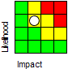 | 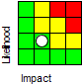 | 24-Mar-2026 | There are a number of actions and strategies in place to deliver best value in procurement. However, the transfer of low complexity procurement to service areas when utilising a framework agreement may be increasing the risk. The risk assessment therefore remains high. Further training and guidance for services has been agreed which should mitigate this risk further. We will continue to review. | Iain Skene
Failure to continue to achieve increased savings from procurement activity | As second or third generation revenue contracts seldom deliver the same cost savings as first generation, the contract strategies need to focus on governance, operating models, total cost of ownership, service quality and innovation | 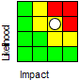 | 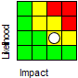 | 24-Mar-2026 | Reduction in staff due to previous Council measures to address the budget gap and global supply chain issues that impact directly on price means that risks to savings will increase. There are also a number of market factors which are difficult to mitigate - increases to employers’ national insurance, fuel prices increases and potential impact of climate change. | Iain Skene

Annex A: Summary of Regulated Procurements
1) Organisation and Report Details
a) Contracting Authority Name |  | West Dunbartonshire Council
b) Period of the annual procurement report |  | 1 April 2025 – 31 March 2026
c) Required by s18 Procurement Reform (Scotland) Act 2014 to prepare an annual procurement report? |  | Yes
2. Summary of Regulated Procurements Completed 1 April 2025 – 31 March 2026
a) Total number of regulated contracts awarded within the report period |  | 88
b) Total value of regulated contracts awarded within the report period |  | £59,222,620
c) Total number of unique suppliers awarded a place on a regulated contract awarded during the period |  | 71
i) how many of these unique suppliers are SMEs |  | 66
ii) how many of these unique suppliers how many are Third sector bodies |  | 6
3. Review of Regulated Procurements Compliance
a) Number of regulated contracts awarded within the period that complied with your  Procurement Strategy |  | 88
b) Number of regulated contracts awarded within the period that did not comply with your Procurement Strategy |  | 0

4. Community Benefit Requirements Summary
a) Total number of regulated contracts awarded with a value of £4 million or greater | 2
b) Total number of regulated contracts awarded with a value of £4 million or greater that contain Community Benefit Requirements | 2
c) Total number of regulated contracts awarded with a value of less than £4 million that contain a Community Benefit Requirements | Not measured in this way*
Key Contract Information on community benefit requirements imposed as part of a regulated procurement that were fulfilled during the period:
d) Number of Jobs Filled by Priority Groups | 7
e) Number of Apprenticeships Filled by Priority Groups | Not measured in this way*
f) Number of Work Placements for Priority Groups | 34
g) Number of Qualifications Achieved Through Training by Priority Groups | Not measured in this way*
h) Total Value of contracts sub-contracted to SMEs | Not measured in this way*
i) Total Value of contracts sub-contracted to Social Enterprises | Not measured
j) Total Value of contracts sub-contracted to Supported Businesses | Not measured
k) Other community benefit(s) fulfilled | Not measured in this way*
* The Council have implemented a more simple measure of local social benefits that supports the aims of the Council’s
Strategic Plan

5. Fair Work and the real Living Wage
a) Number of regulated contracts awarded during the period that included a Fair  Work criterion | 88
b) Number of unique suppliers who have committed to pay the real Living Wage in the delivery of a regulated contract awarded during the period | 88
c) Number of unique suppliers who are accredited Living Wage employers and were awarded a regulated contract awarded during the period | Not measured
d) Number of unique suppliers who have signed up to the Scottish Business Pledge and were awarded a regulated contract awarded during the period | Business Pledge Initiative now closed
6. Payment Performance
a) Number of valid invoices received during the reporting period | 75643
b) Percentage of invoices paid on time during the period (“On time” means within the time period set out in the contract terms) | 90.97%
c) Number of regulated contracts awarded during the period containing a contract term requiring the prompt payment of invoices in public contract supply chains | Not measured
d) Number of concerns raised by sub-contractors about the timely payment of invoices within the supply chain of public contracts | Not measured
7. Supported Businesses Summary
a) Total number of regulated contracts awarded to supported businesses during the period | 0
b) Total spend with supported businesses during the period, including: | £232,716

7. Supported Businesses Summary – continued
i) spend within the reporting year on regulated contracts | £205,896
ii) spend within the reporting year on non-regulated contracts | £26,820
8. Spend and Savings Summary
a) Total procurement spend for the period covered by the annual procurement report | £207,108,570
b) Total procurement spend with SMEs during the period covered by the annual procurement report | Minimum of £86,629,689
c) Total procurement spend with Third sector bodies during the period covered by the report | Not measured in this way
d) Percentage of total procurement spend through collaborative contracts | 14.4% (£29,757,107) * this includes Scottish Government and Scotland Excel frameworks only. No figures for other collaborative bodies spend
e) Total targeted cash savings for the period covered by the annual procurement report | £400,000
i) targeted cash savings for Cat A contracts | Not measured
ii) targeted cash savings for Cat B contracts | Not measured
iii) targeted cash savings for Cat C contracts | Not measured
f) Total delivered cash savings for the period covered by the annual procurement report | £1,732,656
i) delivered cash savings for Cat A contracts | Not measured
ii) delivered cash savings for Cat B contracts | Not measured
8. Spend and Savings Summary – continued
iii) delivered cash savings for Cat C contracts | Not measured
g) Total non-cash savings value | Not measured
9. Future Regulated Procurements 1 April 2023 – 31 March 2025
a) Total number of regulated procurements expected to commence in the next two financial years | 120
b) Total estimated value of regulated procurements expected to commence in the next two financial years | £125,327,918

Annex B: Regulated Procurements
Award Date | Title | Value | Supplier
02/04/2025 | Provision of Scottish Government Counselling in Schools | £309,924 | Lifelink (GB)
08/04/2025 | Purchase of Spin Bikes | £117,689 | Technogym UK Ltd. (GB)
09/04/2025 | Provision of a Near Fatal Overdose Rapid Response Service | £480,795 | Turning Point Scotland Services Ltd (GB)
09/04/2025 | Provision of Services for Multiple and Complex Needs | £480,795 | Turning Point Scotland Services Ltd (GB)
16/04/2025 | Recyclable and Residual Waste - Street Sweepings | £81,097 | J & M MURDOCH & SON LTD (GB)
08/05/2025 | Award of Special Needs Adaptation (External Ramp & Associated Works) to 8 Beech Drive, Clydebank | - | WILLIAM P WHILAND & SON LTD (GB)
13/05/2025 | Integrated Housing Management System | £334,915 | Aareon UK Ltd (GB)
14/05/2025 | Award of Special Needs Adaptation (External Ramp & Associated Works) to 14 Myrtle Road, Clydebank | £16,710 | W H Kirkwood Ltd (GB)
14/05/2025 | Award of Special Needs Adaptation (External Ramp & Associated Works) to 3A Third Avenue, Dumbarto... | £25,546 | William P Whiland & Son Ltd (GB)
19/05/2025 | Children's Services of Child Protection and Child Welfare | £76,900 | Leigh Taylor LTD (GB)
10/06/2025 | Professional services for an Exxon NEC Site Supervisor Role | £389,750 | AtkinsRealis (GB)
10/06/2025 | Trade Materials - Paint & Paint Sundries | £199,971 | Imperial Chemical Industries Ltd T/A ICI Paints Akzonobel (GB)
10/06/2025 | Building & Timber Materials - Building & Roofing Materials | £1,301,268 | D McNair (Builders Merchants) Limited (GB)
17/06/2025 | ICT Device Replacement | £556,000 | HP Inc UK Limited (GB)
17/06/2025 | Award of Extension to Create En-Suite, 9 Cedar Avenue, Clydebank | - | DCF Joiners & Building Services Ltd (GB)
25/06/2025 | Provision of Microsoft Licences for Education | £250,560 | Phoenix Software (GB)
01/07/2025 | Parking Management Back Office Support | £112,271 | Sagoss Limited (GB)
03/07/2025 | The Supply & Delivery of 6 Minibuses 17 Seats | £254,984 | TrustFord Glasgow (GB)
04/07/2025 | The Supply & Delivery of 31 Light Commercial Vehicles | £993,088 | TrustFord Glasgow (GB)
31/07/2025 | Provision of Community outreach addiction services | £145,600 | Alternatives West Dunbartonshire Community Drug Service (GB)
31/07/2025 | Supply, Fit, Repair & Disposal of Tyres for Cars, Vans, Trucks, Agricultural & Plant | £102,400 | McConechy's Tyre Service Ltd (GB)
11/08/2025 | Provision of Community Based Alcohol Support Service | £137,666 | Dumbarton Area Council on Alcohol (GB)
13/08/2025 | Bureau Management Services | £128,160 | Inspired Energy (GB)
26/08/2025 | Supply & Delivery of 3 Refuse Collection Vehicles 26 Tonne | £725,406 | Ciceley Commercials Limited (GB)
28/08/2025 | Supply & Delivery of 3 Multi-Purpose Vehicles (MPV) 7 Seat | £89,736 | TrustFord Glasgow (GB)
04/09/2025 | Cashless Register System for Schools | £162,000 | ParentPay (GB)
17/09/2025 | Award of Factored Owners Survey 2025 | £4,120 | Knowledge Partnership (GB)
19/09/2025 | Provision of Digital TV Maintenance Services | £1,000,000 | MRM Electrical Solutions Ltd (GB)
22/09/2025 | Supply and Delivery of Kitchen Units and Worktops | £647,309 | Joinery & Timber Creations (65) Ltd (GB)
30/09/2025 | West End Day Services | £237,269 | The Mungo Foundation (GB)
01/10/2025 | Supply & Delivery of 2 x 28 Seat Bus with tail lift wheelchair accessible | £294,410 | Woodall-Nicholson Ltd (GB)
02/10/2025 | Supply and Delivery of Laminated Wall Panels | £308,684 | STARK Building Materials UK Ltd (GB)
07/10/2025 | Enterprise Resource Planning (ERP) Software as a Service (SaaS) | £609,236 | Technology One UK Limited (GB)
29/10/2025 | Construction of new 2G MUGAs - Christie Park & Kilbowie Primary Schools | £289,261 | Allsports Construction & Maintenance Ltd (GB)
30/10/2025 | Supply & Delivery of 44 Light Commercial Vehicles | £1,138,314 | TrustFord Glasgow (GB)
05/11/2025 | External Building Fabric Upgrades | £27,500,000 | Ailsa Building Contractors Ltd (GB)
05/11/2025 | Reception, Processing & Treatment of Co-mingled Recyclate | £2,019,619 | Enva (GB)
07/11/2025 | New Build Housing at Queen Mary Avenue | £4,070,785 | CCG (Scotland) Ltd (GB)
14/11/2025 | Award of Mobile Coffee Cart | £13,194 | We Love coffee Ltd (GB)
28/11/2025 | Supply & Delivery of 9 Light Commercial Vehicles | £346,156 | TrustFord Glasgow (GB)
01/12/2025 | Construction of a New 3G Pitch - Milton Park, Milton, Dumbarton | £141,992 | Allsports Construction & Maintenance Ltd (GB)
09/12/2025 | The Upgrade of Balloch Park Play Area | £83,430 | Wicksteed Leisure Ltd (GB)
09/12/2025 | The Upgrade of Dalmuir Park Play Area | £89,213 | Sutcliffe Play Scotland (GB)
09/12/2025 | The Upgrade of Braes Avenue Play Area | £58,935 | Sutcliffe Play Scotland (GB)
18/12/2025 | Purchase Of Compactors | £91,268 | Personnel Hygiene Services Limited (GB)
29/12/2025 | Construction Materials - General Electical Materials | £511,124 | Edmundson Electrical (GB)
29/12/2025 | Construction Materials - Cable Materials | £145,826 | Edmundson Electrical (GB)
29/12/2025 | Edge of Care Service | £199,525 | Includem (GB)
14/01/2026 | Provision of Microsoft Licences for Corporate Users | £635,875 | Phoenix Software (GB)
22/01/2026 | Development of New Allotment Site - Overburn Avenue | £410,292 | P1 Solutions Ltd (GB)
28/01/2026 | Award of Housing First Support | £95,000 | Blue Triangle (GB)
03/02/2026 | Provision of Cleaning Services for temporary accommodation and Void Properties - Lot 1 - Homeless Properties | £170,155 | New Two (GB)
03/02/2026 | Legionella Water Management Contract | £560,000 | Envirocure Ltd (GB)
09/02/2026 | Supported Housing | £334,815 | Blue Triangle (GB)
17/02/2026 | Provision of Cleaning Services for temporary accommodation and Void Properties - Lot 2 - Void Properties | £127,900 | CAMPBELL CLEANING SERVICES (GB)
18/02/2026 | Provision of Adult Residential Respite Service - Dunn Street | £645,809 | Quarriers (GB)
24/02/2026 | Supply & Delivery of 32 tonne Hooklift Vehicle | £167,262 | Ciceley Commercials Limited (GB)
25/02/2026 | Supply & Delivery of 4 x 11 Tonne Food Refuse Collection Vehicles | £494,032 | Farid Hillend Engineering Limited (GB)
26/02/2026 | 2526-58 Supply & Delivery of 3 minibuses 17 Seat | £117,328 | TrustFord Glasgow (GB)
02/03/2026 | Supply & Delivery of Gully Waste 18t Jetter Vehicle | £275,000 | WHALE TANKERS LIMITED (GB)
02/03/2026 | Award of 24/7 Mental Health platform for West Dunbartonshire residents for Working 4U and Educati... | £50,000 | Togetherall (GB)
02/03/2026 | Construction Materials Sub Lot 1 Wiring Materials | £42,301 | Edmundson Electrical (GB)
05/03/2026 | Alexander Street Public Realm Improvement Project | £340,154 | M Squared (Scotland) Ltd (GB)
05/03/2026 | Award of Call Off NEC4 GCC Short Form Clydebank Road Markings | £44,231 | Mainline Roadmarking Ltd (GB)
05/03/2026 | Award of Call Off NEC4 GCC Short Form Dumbarton & Alexandria Road Markings | £36,583 | Mainline Roadmarking Ltd (GB)
10/03/2026 | New Build Housing at O'Hare | £1,537,004 | The JR Group (GB)
13/03/2026 | Ground Maintenance Plant / Vehicle - 3 x Wacker Neuson Excavators | £66,900 | HAMILTON BROS. (ENGINEERING) LTD (GB)
18/03/2026 | Ground Maintenance Plant / Vehicle - 12 x SCAG Machinery | £144,714 | FRASER C ROBB LIMITED (GB)
19/03/2026 | Ground Maintenance Plant / Vehicle - 7 x John Deere Machinery | £263,093 | The Double A Trading Company (GB)
31/03/2026 | Provision of Addiction Services | £2,800,000 | We Are With You (GB)

Annex C: Non-Compliant Regulated Spend
Procurement Title | Estimated Annual Spend | Actions
Social Care and Services | £4,398,704 | HSCP has workplan established
Education | £1,822,072 | Education / HSCP has workplan established
Agency | £1,820,594 | HSCP has workplan established
Social Care and Services | £1,288,465 | HSCP has workplan established
Education | £1,125,604 | Education / HSCP has workplan established
Agency | £1,074,105 | HSCP has workplan established
Social Care and Services | £989,991 | HSCP has workplan established
Agency | £777,020 | HSCP has workplan established
Social Care and Services | £753,646 | HSCP has workplan established
Education Capital | £347,648 | One off spend
Agency | £293,583 | HSCP has workplan established
Agency | £289,119 | HSCP has workplan established
Social Care and Services | £241,254 | HSCP has workplan established
Agency | £163,808 | HSCP has workplan established
Education Capital | £160,392 | Checking with service area
Housing Capital | £156,871 | One off spend
Agency | £154,547 | HSCP has workplan established
Social Care and Services | £153,513 | HSCP has workplan established
Logistics | £133,383 | To engage with service area
Employability | £122,633 | To engage with service area
Pest Control | £100,338 | To engage with service area
Capital | £100,135 | One off spend
Housing Supplies | £88,813 | To engage with service area
Blacksmiths | £63,819 | Potential future tender
Joinery | £58,477 | Being tendered
PAT Testing | £58,197 | To engage with service area
Plumbing | £57,617 | Being tendered
Energy Billing | £56,645 | To engage with service area
Audio Visual | £51,522 | To engage with service area
Housing Promotion | £51,137 | One off spend
Vehicle Hire | £51,099 | To engage with service area

Annex D: Future Regulated Procurement
Procurement Title | Estimated Total Value | End Date  (including extensions)
Services: Purchase Egress Defend | £127,928 | 01/04/2026
Provision of Emergency Placement for 24hr Residential | £568,000 | 03/04/2026
Supply of Domestic Furniture and Furnishings | £1,200,000 | 24/04/2026
Provision Access Platform Hire | £60,000 | 24/04/2026
12 x SCAG Machinery - Provision of Grounds Maintenance plant/vehicles | £500,000 | 30/04/2026
Employee benefits (Viv-up) | £0 | 30/04/2026
3 x Wacker Neuson ET18D Tracked Excavators - Provision of Grounds Maintenance plant/vehicles | £500,000 | 30/04/2026
Rental and Maintenance of Automated Public Conveniences | £1,838,683 | 01/05/2026
7 x John Deere Machinery - Provision of Grounds Maintenance Plant / Vehicle | £500,000 | 01/05/2026
Provision of Emergency Placement for 24hr Residential | £204,000 | 08/05/2026
Provision of 24Hour Residential / Nursing Care Within a Care Home Setting - P25787 | £149,656 | 08/05/2026
Works: Balloch Park - Refurbishment of 3 play areas | £90,000 | 25/05/2026
Works: Dalmuir Park - Refurbishment of 3 play areas | £90,000 | 25/05/2026
Works: Braes Avenue - Refurbishment of 3 play areas | £60,000 | 25/05/2026
Provision of Dunbartonshire Argyll & Bute Valuation Joint Board Print and Mail Services | £420,000 | 31/05/2026
Provision of 24Hour Residential / Nursing Care Within a Care Home Setting - P75288 | £64,199 | 06/06/2026
Emergency Provision of 24Hr Residential / Nursing Care Within a Care Home Setting (P29862) | £64,199 | 26/06/2026
Design & Build Mount Pleasant New Build Housing | £4,606,023 | 10/07/2026
Provision of NCHC 24Hour Residential / Nursing Care within a Care Home Setting - P63780 | £177,091 | 14/07/2026
Provision of Non-NCHC 24Hour Residential / Nursing Care within a Care Home Setting - P119830 | £156,000 | 14/07/2026
Library Books & Textbooks - Call off from SXL | £0 | 31/07/2026
Wireless Licensing Meraki Contract | £264,000 | 01/08/2026
Subcontractors Framework Agreement Flooring | £330,000 | 07/08/2026
Subcontractors Asbestos Surveys | £384,000 | 07/08/2026
Specialist Roofing - Flat Roofing and Metal Roofing | £4,000,000 | 08/08/2026
Subcontractors Lot 1 Landscaping Rank 1 | £3,100,000 | 08/08/2026
Measured Term Contract for Internal Window Finishes | £155,000 | 08/08/2026
Measured Term Contract Modern Facilities Installations and Improvements | £3,050,000 | 08/08/2026
Measured Term Contract for UPVC Windows & Doors | £3,260,258 | 08/08/2026
Development of New Allotment Site - Overburn | £280,000 | 08/08/2026
Subcontractors Lot 4 Scaffolding | £2,300,000 | 09/08/2026
Subcontractors Lot 8 Plumbing | £300,000 | 09/08/2026
Subcontractors Lot 10 Asbestos Removals 1st Ranked | £768,000 | 09/08/2026
Subcontractors Lot 10 Asbestos Removals 2nd Ranked | £768,000 | 09/08/2026
Provision of 24Hour Residential / Nursing Care within a Care Home Setting - P163224 | £156,000 | 18/08/2026
Subcontractors Lot 1 Landscaping Rank 2 | £3,100,000 | 19/08/2026
Purchase of Vans, Light Goods Vehicles and Heavy Goods Vehicles | £1,889,274 | 31/08/2026
Call Manager Telephony System - Upgrade and Maintenance | £166,180 | 18/09/2026
Modular Construction of 2 x 3 Bed Semi-Detached Houses At 7-9 Gilmour Avenue, Hardgate, Clydebank | £548,151 | 22/09/2026
Subcontractors Lot 5 Electrical Specialist | £450,000 | 03/10/2026
Subcontractors Lot 7 Laundry Equipment Rank 1 | £97,500 | 03/10/2026
Subcontractors Lot 7 Laundry Equipment Rank 2 | £97,500 | 03/10/2026
Provision of NCHC 24Hour Residential / Nursing Care within a Care Home Setting - P103717 | £173,077 | 18/10/2026
Provision of NCHC 24Hour Residential / Nursing Care within a Care Home Setting - P158161 | £173,077 | 26/10/2026
Provision of CallConfirm Live Support | £342,000 | 30/10/2026
Provision of NCHC 24Hour Residential / Nursing Care within a Care Home Setting - P171262 | £173,701 | 06/11/2026
Microsoft 365 Backup Solution | £257,594 | 13/11/2026
Supply and Fit of Environmental Sensors | £6,000,000 | 20/11/2026
Provision of NCHC 24Hour Residential / Nursing Care within a Care Home Setting - P75524 | £173,077 | 18/12/2026
Queen Mary Avenue Design and Build | £4,070,785 | 19/12/2026
Provision of LD Services: Residential Care Including Respite | £645,809 | 31/12/2026
Collection, Haulage, Processing, Treatment and Disposal Bulky Waste | £5,735,160 | 31/12/2026
Services: Provision of Tyres for Cars & vans and Tyres - Trucks | £112,000 | 31/01/2027
Measured Term Contract for Lifts | £207,350 | 01/02/2027
Services: Bairn's Hoose Services | £112,350 | 01/02/2027
Provision of NCHC 24Hour Residential / Nursing Care within a Care Home Setting - P11539 | £173,077 | 06/02/2027
Provision of an IHMS Upgrade | £250,000 | 07/02/2027
SIP Trunking Project - Telephone Line Replacement | £890,000 | 24/02/2027
Treatment of Organic Waste - Comingled Food & Garden | £585,000 | 27/02/2027
Treatment of Organic Waste - Lot 1 Food Waste | £9,200 | 27/02/2027
Treatment of Organic Waste - Lot 2 Garden Waste | £30,420 | 27/02/2027
Supply of Fire Fighting Equipment | £120,000 | 19/03/2027
Services : Connected Response | £834,800 | 29/03/2027
Provision of Fresh Meats | £554,357 | 30/03/2027
Provision of Cooked Meat | £554,357 | 30/03/2027
Supply of Fresh Fruit and Vegetables | £639,166 | 31/03/2027
Insurance Services for Right to Buy Block Buildings Administered by WDC | £3,670,935 | 31/03/2027
Provision of a Cycle to Work Scheme | £250,000 | 31/03/2027
Maintenance and Repair of Cleaning Equipment | £35,186 | 31/03/2027
Supply and Delivery of Bread, Rolls and Baked Goods | £180,512 | 31/03/2027
Provision of Frozen Foods | £3,674,234 | 31/03/2027
Provision of Fresh Fish | £1,663,070 | 31/03/2027
Provision of Carefirst Support and Maintenance | £405,051 | 31/03/2027
Services: Day Care Services - West End Project Dumbarton | £454,103 | 31/03/2027
Provision of NCHC 24Hour Residential / Nursing Care within a Care Home Setting - P150170 | £178,002 | 06/04/2027
Provision of NCHC 24Hour Residential Nursing Care within a Care Home Setting - P3988 | £80,704 | 28/04/2027
Provision of Debt Management Partners | £100,000 | 01/05/2027
Community Link Worker | £1,059,211 | 02/05/2027
Hire of Skips for West Dunbartonshire Council | £130,000 | 07/05/2027
Services: Children’s Services for child protection and child welfare | £76,900 | 21/05/2027
Purchase of 3 x Tractors | £150,000 | 31/05/2027
Servicing and Maintenance of Mechanical Installations at West Dunbartonshire Non Housing Properties | £748,000 | 01/06/2027
Parking Management Back Office Support | £200,000 | 01/06/2027
Appointment of a Delivery Agent for Elements of the Exxon Site Development | £1,000,000 | 05/06/2027
Supply of Personal Protective Equipment | £244,969 | 22/06/2027
Maintenance and Repair of Catering Equipment | £137,786 | 30/06/2027
Storage Array Network (SAN) Replacement | £390,000 | 04/07/2027
Professional Services for Willox Park | £77,920 | 27/07/2027
Provision of Insurance Services (including Claims Handling) for West Dunbartonshire Council (WDC) & West Dunbartonshire Leisure Trust (WDLT) | £7,064,959 | 31/07/2027
Provision of Insurance Services (including Claims Handling) for West Dunbartonshire Council (WDC) & West Dunbartonshire Leisure Trust (WDLT) | £352,685 | 31/07/2027
Provision of Tile Hoist Hire | £160,000 | 20/08/2027
Provision National Care Home Contract Ashley House Care Home | £184,808 | 03/09/2027
Provision of a NCHC for 24Hour Residential Nursing Care within a Care Home Setting - P20315 | £184,808 | 04/09/2027
Provision of Recycling of Obsolete Hardware | £0 | 16/09/2027
Digitisation of Archives and Local Studies Materials | -£16,096 | 19/09/2027
Services: Microsoft Sharepoint M365 Collaboration, Phase 2 implementation | £200,000 | 24/09/2027
Services: Professional services for Exxon NEC4 Project Site Supervisor role | £0 | 06/10/2027
Alexander Street Public Realm Improvement Project – Main Construction Contractor Appointment | £471,000 | 06/10/2027
Specialist roofing repairs and maintenance. | £1,500,000 | 07/10/2027
Provision of Groceries | £1,268,605 | 15/10/2027
Provision of Small Plant Hire, Repair and Ancillary Supplies & Services | £340,000 | 29/10/2027
Provision of Welfare Hire | £224,000 | 29/10/2027
Services: Provision of Purchasing Cards | £0 | 29/10/2027
Mechanical & Electrical Engineers - Bank Street & Bonhill Gap Sites | £58,250 | 19/11/2027
Civil & Structural Engineers - Bank Street & Bonhill Gap Sites | £39,050 | 20/11/2027
Exxon Construction at the Former Bowling Site, Milton | £34,000,000 | 06/12/2027
Provision of 24 Hour Residential Nursing care within a care home setting | £208,851 | 15/12/2027
Goods: Purchase of Netbackup software licencing subscription | £90,000 | 31/12/2027
Provision of Removals, External Environmental Works and Needle Sweep Services | £620,533 | 07/01/2028
Fleet Replacement Programme - Purchase of 1 x heavy goods vehicles (13.5T RCV) | £155,000 | 09/01/2028
Fleet Replacement Programme - Purchase of 5 x heavy goods vehicles (18T Multi Body - Roads) | £675,000 | 09/01/2028
Provision of Occupational Health Services | £700,000 | 18/01/2028
Fleet Replacement Programme - Supply & Delivery of 23 Small Hybrid Cars | £414,000 | 19/01/2028
Provision of Merchant Card Acquiring Services | £480,000 | 01/02/2028
Services: Supported Housing | £468,000 | 02/02/2028
Provision of Object Based Storage to Replace the Data Domains | £150,000 | 28/02/2028
Provision of Annual Billing for Council Tax and Housing Benefit Letters | £40,000 | 28/02/2028
Services Voice & Data Services Framework - Vodafone Contract renwal | £124,800 | 12/03/2028
Care Monitoring Software | £126,030 | 31/03/2028
Services: Brain Health and Dementia Resource Centre | £481,057 | 31/03/2028

